PROJECT REPORT
AUTO TICKET CLASSIFICATION USING FLOW DESIGNER - SCHOOL IT HELPDESK
ServiceNow Project

Team Leader : Sanjay S
Team Member: Arun Kumar S
Team Member: Deepak Raj K
Team Member: Harish V
Team I'd : 6ab623eedcdae33acb38f1f2
Team Name : Team 7

1. INTRODUCTION

1.1 Project Overview
The School IT Helpdesk project provides an automated way to classify IT support tickets created by students and teachers. Common requests include Wi-Fi issues, projector failures, password or login problems, and slow computers.
The solution uses ServiceNow Flow Designer to analyze keywords in the ticket short description and automatically assign the appropriate Category and Subcategory. It also sends an email notification to the caller after the ticket is created.
The project is designed as a no-code solution so that it is easy to maintain, demonstrate, and extend for a school environment.

1.2 Purpose
- Automatically classify school IT incidents when they are created.
- Reduce the manual effort required from IT support staff.
- Improve ticket routing and classification consistency.
- Use dependent Category and Subcategory choices to improve data accuracy.
- Send an automatic confirmation email to the caller.
- Provide a structured and scalable IT helpdesk workflow.

2. IDEATION PHASE

2.1 Problem Statement
The school IT helpdesk receives multiple incident requests daily from students and teachers, such as Wi-Fi issues, projector failures, password problems, and slow computers. Currently, IT staff manually review each request and assign a category. This process is time-consuming, can lead to classification errors, and becomes difficult to manage as the number of requests increases.
The proposed project automates ticket classification using ServiceNow Flow Designer by analyzing keywords in the incident short description and description fields.

2.2 Empathy Map Canvas
Area | User Perspective
Says | “My Wi-Fi is not working”, “The projector is not turning on”, “I forgot my password”, or “My computer is very slow.”
Thinks | The issue should be recorded quickly and routed to the correct IT support area.
Does | Creates an IT support ticket and provides a short description of the problem.
Feels | Wants a quick acknowledgement and clear confirmation that the request has been submitted.
Pain Points | Manual classification can delay routing and may result in incorrect category selection.
Needs | Simple ticket creation, automatic classification, accurate data, and confirmation by email.

2.3 Brainstorming
- Automatically identify common IT issues using keywords.
- Use Flow Designer instead of complex scripting.
- Automatically set Category and Subcategory.
- Use dependent choices so Subcategory options match the selected Category.
- Send an automatic email notification to the caller.
- Store ticket information in a structured custom table.
- Keep the design maintainable and scalable for future helpdesk requirements.

3. REQUIREMENT ANALYSIS

3.1 Customer Journey Map
Stage | User Action | System Action | User Outcome
1. Identify Issue | Student/teacher notices an IT problem. | No action yet. | Needs IT assistance.
2. Create Ticket | Enters caller and short description. | Ticket is stored in Incident Workflow table. | Request is recorded.
3. Automatic Classification | Waits for ticket processing. | Flow Designer checks keywords. | Category and Subcategory are assigned.
4. Notification | Receives confirmation. | Email is sent to caller. | Knows that the request was submitted.
5. IT Processing | IT staff can review structured data. | Ticket contains standardized classification. | Ticket is easier to manage and route.

3.2 Solution Requirement
- Automatically classify IT tickets based on the issue description.
- Assign both Category and Subcategory without manual intervention.
- Support dependent choice logic between Category and Subcategory.
- Send an automated email notification to the caller upon ticket creation.
- Store ticket information in a structured and standardized format.
- Ensure easy maintenance and future scalability.

3.3 Data Flow Diagram
The data flow begins when a student or teacher creates an IT support ticket. The ticket is stored in the Incident Workflow table and passed to Flow Designer. Flow Designer checks the short description for predefined keywords, assigns the relevant Category and Subcategory, and sends an email confirmation to the caller.
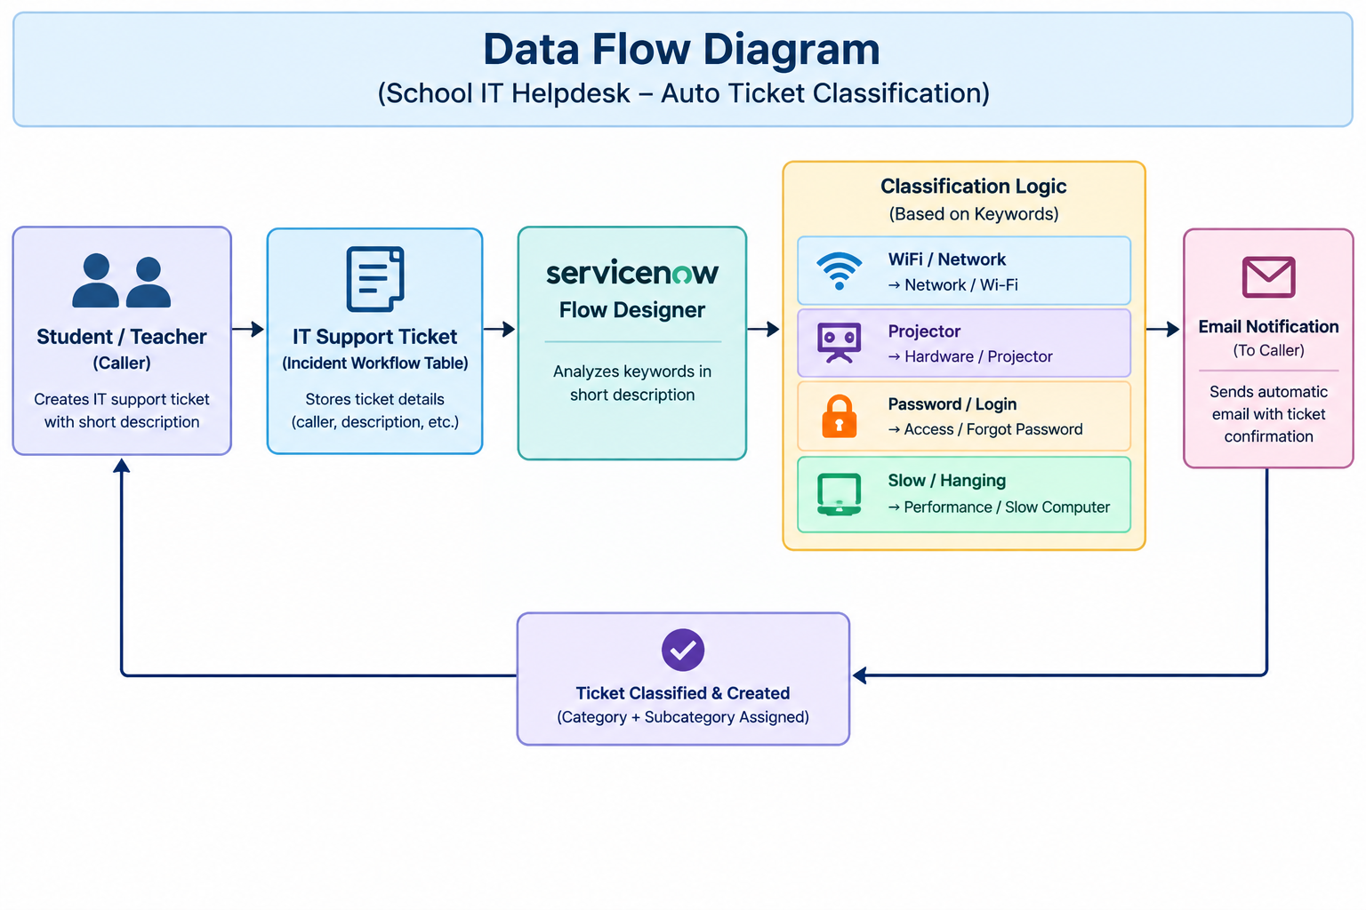
Figure 1: Data Flow Diagram – School IT Helpdesk

3.4 Technology Stack
Technology / Component | Purpose
ServiceNow Platform | Main platform for the school IT helpdesk solution.
Flow Designer | No-code automation and ticket classification.
Incident Workflow Custom Table | Stores structured school IT ticket records.
Choice Fields | Stores Category, Subcategory, and State values.
Reference Fields | Connects Caller, Assigned Group, and Assigned To records.
Email Action | Sends automated ticket confirmation to the caller.
Update Sets | Packages configuration changes for deployment.

4. PROJECT DESIGN

4.1 Problem Solution Fit
Problem | Proposed Feature | Expected Improvement
Manual ticket classification | Keyword-based Flow Designer automation | Less manual effort
Incorrect Category/Subcategory selection | Dependent choice fields | Improved data consistency
Caller does not know whether ticket was submitted | Automatic email notification | Immediate acknowledgement
Growing number of requests | Structured custom table and no-code flow | Better maintainability and scalability

4.2 Proposed Solution
The proposed solution creates a custom Incident Workflow table in ServiceNow and configures fields such as Caller, Category, Subcategory, Short Description, Description, State, Assigned Group, and Assigned To. Category and Subcategory use dependent choice logic.
A Flow Designer flow named “Auto Classify School IT Tickets” is triggered when a new record is created and Category is empty. The flow evaluates the short description and applies predefined classification rules:
- Wi-Fi / Network → Category: Network; Subcategory: Wi-Fi.
- Projector → Category: Hardware; Subcategory: Projector.
- Password / Login → Category: Access; Subcategory: Forgot Password.
- Slow / Hanging → Category: Performance; Subcategory: Slow Computer.
After classification, Flow Designer sends an email to the caller confirming that the request has been submitted.

4.3 Solution Architecture
The architecture connects school users, the ServiceNow platform, the custom ticket table, Flow Designer automation, keyword-based classification logic, email notification, and structured data storage.
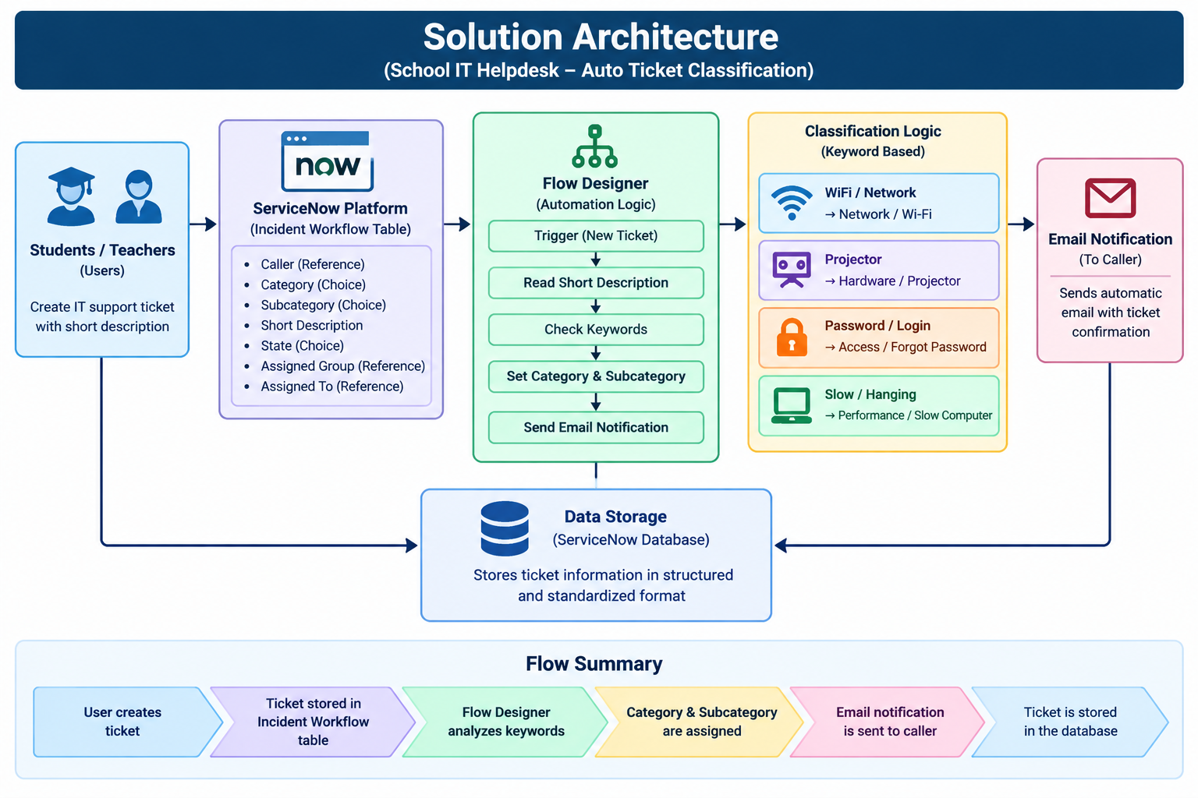
Figure 2: Solution Architecture – School IT Helpdesk

5. PROJECT PLANNING & SCHEDULING

5.1 Project Planning
Phase | Major Activity | Output | Status
Phase 1 | Requirement analysis and update set creation | Requirements and Project Update Set | Completed
Phase 2 | Custom table and field configuration | Incident Workflow table | Completed
Phase 3 | Category/Subcategory dependency | Dependent choice configuration | Completed
Phase 4 | Flow Designer automation and email | Auto classification flow | Completed
Phase 5 | Testing and validation | Validated test scenarios | Completed
Phase 6 | Deployment and documentation | Completed update set and report | Completed

6. FUNCTIONAL AND PERFORMANCE TESTING

6.1 Performance Testing
Testing validates that the end-to-end automation works as expected, that ticket information is stored correctly, and that classification and email notification occur after ticket creation.
Test Case | Input / Scenario | Expected Result | Actual Result | Status
TC01 | WiFi not working in library | Category = Network; Subcategory = Wi-Fi; email sent | Matches expected behavior | Pass
TC02 | Projector not turning on | Category = Hardware; Subcategory = Projector; email sent | Matches expected behavior | Pass
TC03 | Password/Login issue | Category = Access; Subcategory = Forgot Password | Flow rule assigns access classification | Pass
TC04 | Slow/Hanging computer | Category = Performance; Subcategory = Slow Computer | Flow rule assigns performance classification | Pass
TC05 | Auto-number generation | Unique ticket number generated | Ticket number generated without duplication | Pass
TC06 | Reference validation | Caller and group references resolve correctly | Reference fields resolve correctly | Pass
Data validation checks include mandatory field capture, unique auto-number generation, accurate Category and Subcategory values, and correct resolution of reference fields.

- OUTPUT SCREENSHOTS

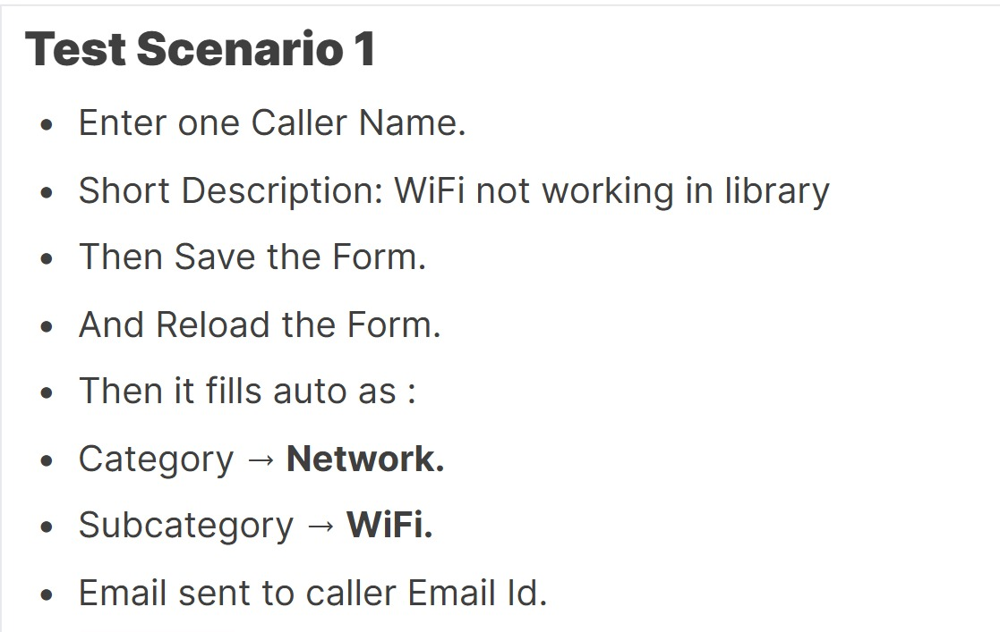

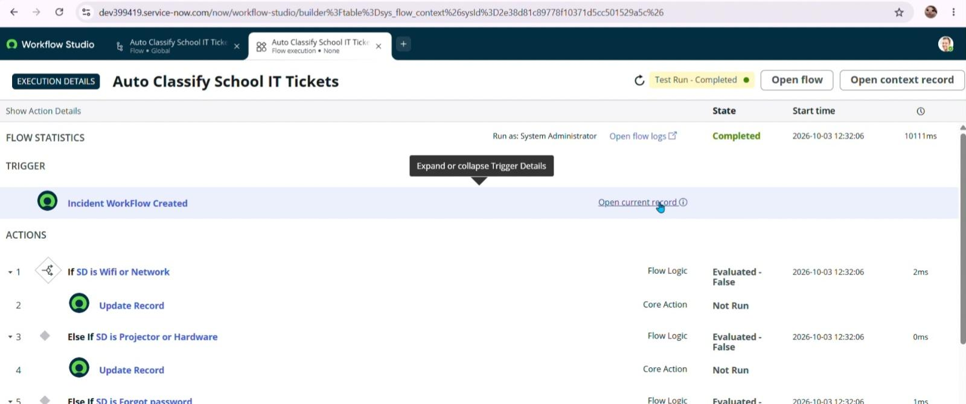
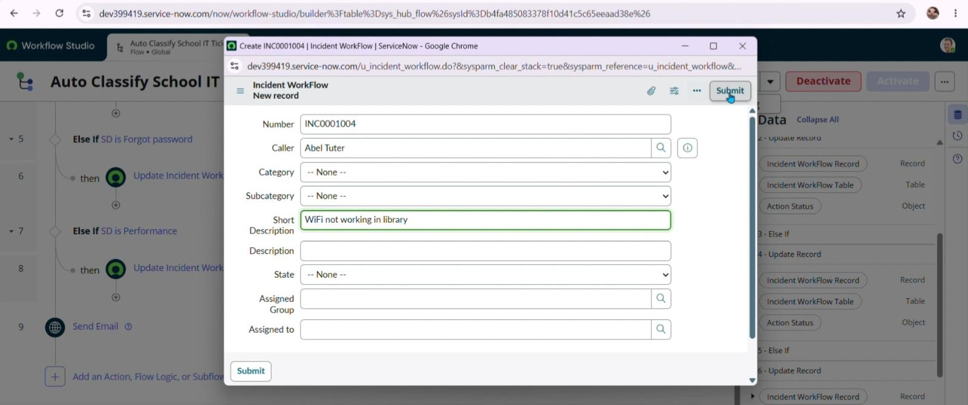

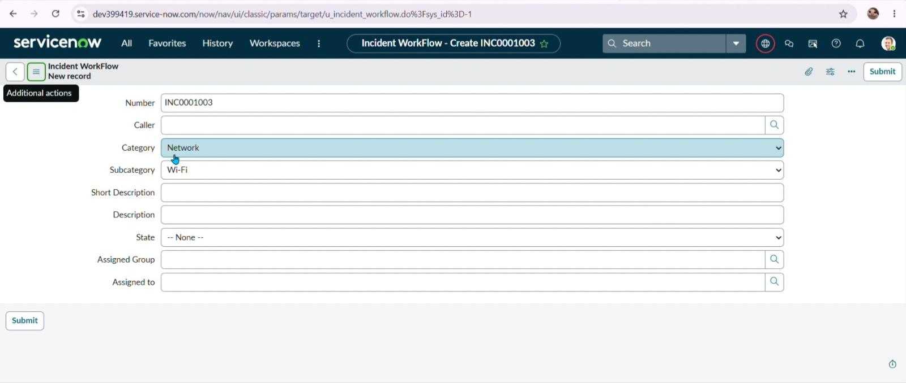

8. ADVANTAGES & DISADVANTAGES

Advantages
- Reduces manual ticket classification effort.
- Provides consistent Category and Subcategory assignment.
- Uses no-code Flow Designer automation.
- Improves ticket data consistency through dependent choices.
- Provides immediate email acknowledgement to the caller.
- Easy to maintain and extend with additional rules.
- Suitable for school IT helpdesk environments.

Disadvantages
- Keyword-based classification depends on the wording used in the ticket.
- New issue types require additional classification rules.
- The current solution does not use machine learning or natural-language understanding.
- Email notification depends on correct caller email information.
- Complex or ambiguous descriptions may require additional rules or manual review.

9. CONCLUSION
The Auto Ticket Classification using Flow Designer project provides a complete end-to-end automation solution for a school IT helpdesk. The primary objective of reducing manual effort in ticket categorization and improving response efficiency is addressed through automatic classification.
The solution uses structured requirement analysis, ServiceNow backend configuration, dependent choice fields, and no-code Flow Designer automation. Tickets are classified based on keywords in the short description, and automated email notifications acknowledge ticket creation to the caller.
The phased implementation supports clarity, testing, maintainability, and deployment through Update Sets. The solution can be extended in the future with additional automation and service-management features.

10. FUTURE SCOPE
- Automatic assignment of tickets to specific IT support groups or technicians.
- SLA tracking and escalation for unresolved school IT incidents.
- Additional classification rules for more school-specific IT issues.
- Integration with knowledge articles for self-service support.
- Predictive or intelligent classification for more complex ticket descriptions.
- Dashboards and reports for helpdesk workload and issue trends.
- Additional notifications for ticket status changes and resolution.

11. APPENDIX

A. Configuration Summary
Update Set: Project Update Set | Application: Global | State during development: In Progress.
Custom Table: Incident Workflow. Auto Number is enabled.
Field | Type | Values / Reference
Number | Auto Number | —
Caller | Reference | sys_user
Category | Choice | Network, Hardware, Access, Performance
Subcategory | Choice | Wi-Fi, Projector, Forgot Password, Slow Computer
Short Description | String | —
Description | String | —
State | Choice | New, In progress, On hold, Resolved, Closed
Assigned Group | Reference | sys_user_group
Assigned to | Reference | sys_user

B. Classification Rules
Keyword / Issue | Category | Subcategory
Wi-Fi / Network | Network | Wi-Fi
Projector | Hardware | Projector
Password / Login | Access | Forgot Password
Slow / Hanging | Performance | Slow Computer

C. Source Code
No conventional source code is required for the core automation. The solution is implemented using ServiceNow configuration and Flow Designer no-code actions.

D. Dataset Link
Not applicable. The project uses ServiceNow ticket records rather than an external dataset.

E. GitHub & Project Demo Link
GitHub link-
https://github.com/Sanjay-026/Auto-Ticket-Classification-using-Flow-DesignerF. Deployment Summary

Demo link -
https://drive.google.com/drive/folders/1L7WSrf0KXTknjwyyF04eEXGDrMzkW3Jr?usp=drive_linkOpen Local Update Sets and select Project Update Set.

F. Summary
- Change the Update Set state from In Progress to Complete.
- Save the record.
- Use Export to XML to download the Update Set.
- The exported Update Set can be shared and imported into another ServiceNow environment.

